Lab: Input Sets

In this lab, you will create an input set that contains specific widgets for a contact's email addresses.

Requirements

This lab requires that you use TrainingApp 8.0, Guidewire Studio 8.0, and Chrome as your web browser. To view, edit, and delete various contacts, log in to TrainingApp as Alice Applegate. The default URL for TrainingApp is <http://localhost:8880/ab/ContactManager.do>. The login/password for Alice Applegate is aapplegate/gw.

1. Create an Input Set

In this exercise, you will first create an input set. Next, you will add widgets for a contact's main and alternate email addresses to the input set. Then, you will add your input set to various PCFs.

Part A

In Part A of this exercise, you will create the EmailAddressInputSet.

Configuration

1. Open Guidewire Studio for TrainingApp
2. Create a new PCF named EmailAddressInputSet
3. Create the input set in the traininglabs PCF folder.
4. Specify a root object of the type ABContact.
5. Add widgets
6. Add a label widget that displays "Email Addresses".
7. Add an editable input widget labeled "Main" that displays ABContact's EmailAddress1 field.
8. Add an editable input widget labeled "Alternate" that displays ABContact's EmailAddress2 field.

Part B

In Part B of this exercise, you will add the EmailAddressInputSet to the ABContactSummaryDV.

Configuration

1. Navigate to ABContactSummaryDV
2. In the canvas, hide included sections.
3. Add the EmailAddressInputSet to ABContactSummaryDV
4. Add an input divider below the Primary Address section in the same input column.
5. Reference the EmailAddressInputSet directly below the input divider.
6. In the canvas, show included sections.

Deployment

1. Deploy your changes
2. From Studio, restart the server using Debug 'Server'.
3. Review the Debug console for errors.
4. Verify that the application is running in the Debug console.

Part C

In Part C of this exercise, you will add the EmailAddressInputSet to both the ABContactDetailsCV.ABPerson.pcf and ABContactDetailsCV.ABCompany.pcf files.

Configuration

1. Navigate to ABContactDetailsCV.ABPerson
2. In the canvas, hide included sections.
3. Select the Phone & Addresses card.
4. Add the EmailAddressInputSet
5. Reference the EmailAddressInputSet directly below the Primary Address section in the same input column.
6. In the canvas, show included sections.
7. Navigate to ABContactDetailsCV.ABCompany
8. In the canvas, hide included sections.
9. Select the Phone & Addresses card.
10. Add the EmailAddressInputSet
11. Reference the EmailAddressInputSet directly below the Primary Address section in the same input column.
12. In the canvas, show included sections.

Verification

1. Log in to TrainingApp
2. Log in as Alice Applegate.
3. Reload the PCF changes
4. In TrainingApp, reload the changes to the PCF file(s).
5. Edit the William Andy contact
6. Search for William Andy.
7. In the search results list view, navigate to the William Andy contact.
8. In the Summary, edit the contact.
9. Enter a Main email for William Andy, e.g., william@guidewire.com.
10. Enter an Alternate email for William Andy, e.g., william_andy@guidewire.com.
11. Click Update.

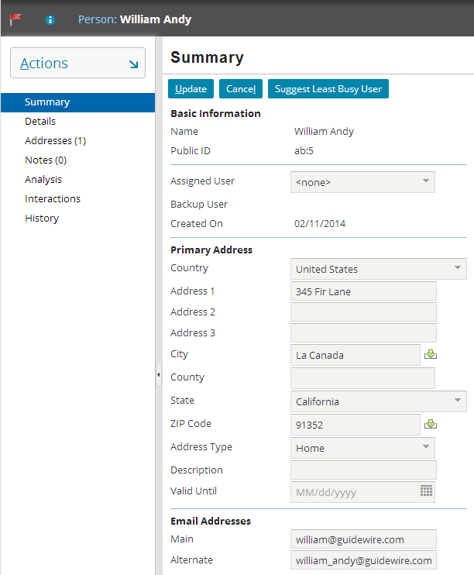

1. View the William Andy contact details
2. In the sidebar menu, click Details.
3. In Details, click Phone & Addresses.
4. Verify that you see the email addresses that you entered.

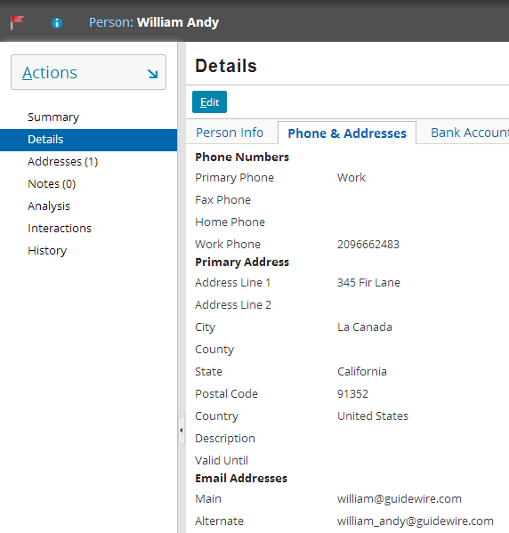

|  |  |
| --- | --- |
|  | Stop and ask your instructor to review your completed lab. |